**WHEEL-X**

**(SMART VEHICLE SYSTEM)**

***Problem Statement:***

The necessity of this project is because of vehicle burglary (especially cars), The news THE TIMES OF INDIA › says that in Delhi, nearly 121 cars being stolen a day in 2020 and it raised up to 160 in 2022. Even our country’s capital Delhi’s CM car is also one among the 121. So, I made this as our problem statement and worked on this. Here we come to a point there are several protective measures including buzzers also GPS tracking but still robbery takes place. To prevent such vehicle robberies and keeping economic conditions in mind, making this as a PROBLEM STATEMENT. And this needs to be really considered.

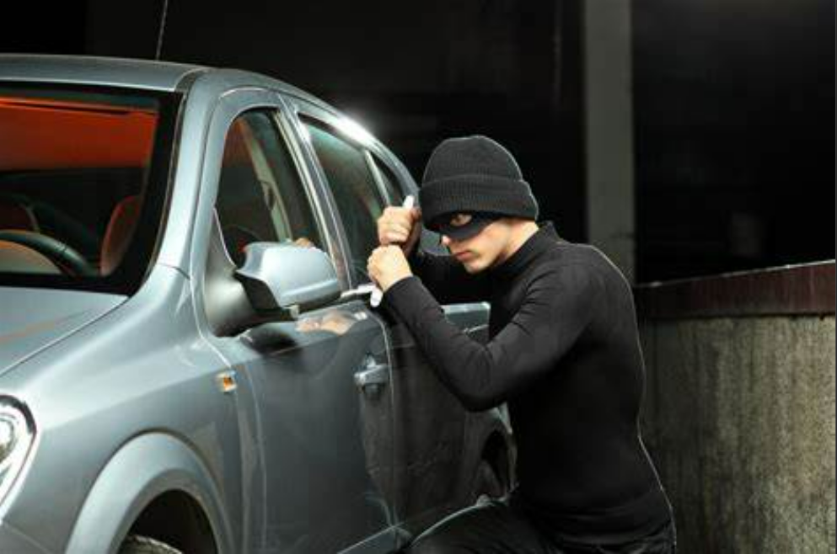

***Solution:***

The main concept of our project is to unlock our automobiles by using our fingerprint as key and to sense our automobiles safety in mobile, PC or any other electronic gadgets using IOT. It is highly safe control of the automobiles from other person because, the idea implied by our team is similar to a mobile’s finger print lock. Today, technology has made the unbelievable and impossible things possible and greatly reduced man power also solved major problems in industries and gave high profit for industries. Technology has also solved very much day-to-day life problems. The main motto of this project is to get awareness from automobiles theft. First, this project is combination of several ideas to make things safe, simple, economical friendly. But this project is one of the best and simpler for installation and tougher for burglars who try to steal our vehicles.

**Working of the Wheel-X:**  
The working of this project is simple. Initially, the finger print of the vehicle holder is recorded with his finger prints once. Our sensor has the capacity of 11 fingers. So, it can also use for company or management’s common vehicle purpose. Now the circuit is connected with vehicle’s supply. When the correct finger print placed on sensor of vehicle it works and vehicle starts (Ignition Process Initiates) and if some wrong finger print records produce buzzer alarm and automatically updates the wrong finger intimation in a website where we installed through IOT. Also, the live location (Latitude and Longitude) will be displayed in the below given website which is commonly accessible by anyone in Internet connected devices.

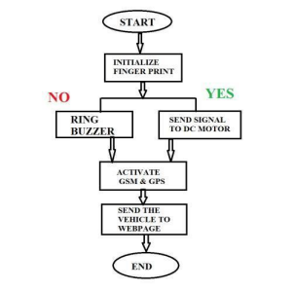

**Communication needs:**

If a sim card is placed in the GSM Module with internet connectivity and main balance, the IOT Circuit gets completed. If a correct finger print gets recorded the data with date, time, employer id (within 11 persons ) and its live location gets recorded and that data is published in the website or webpage we designed. Here the output webpage we provide is [vehicleiot.in/finger/view.php?key=Alert ]. Even if wrong finger print gets recorded the data is stored in form of date, time,location and message mentioned “ALERT”.

**Components Used in our Device:**

1. 12v supply ( Battery )

2. 12v DC Motor ( Instead of bike engine )

3. LED Board

4. Fingerprint Sensor

5. Switch

6. Toy Wheel ( For better view of rotation of motor )

7. Buzzer

8. Relay

9. Arduino Board

10. GSM Module

11. GPS Board and Antenna

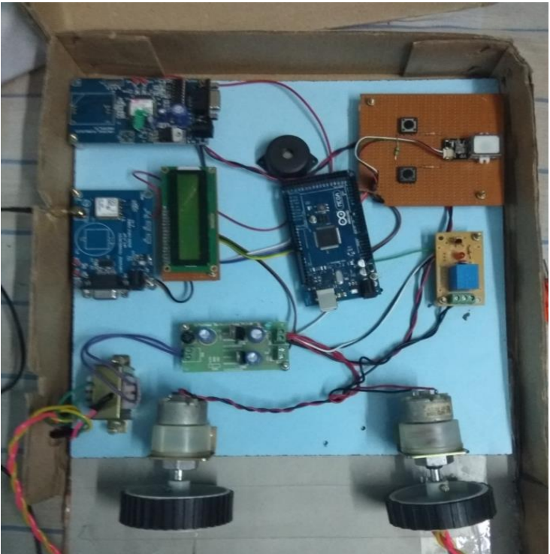

**Novelty:**

Assume in a shed if a vehicle with our project and 9 vehicles with normal lock system found, it is damn sure the rest 9 can only get harm. This situation is similar if 9 vehicles of our project and 1 normal lock system bike found. 10 percent chances are there that the normal bike will only get stolen. Finally, not leaving this project as end, am planning to upgrade our project to next level with installation of fuel and air level sensors to the website also with wrong finger impression recordable memory card storage. Because, if the wrong or mismatch finger prints get recorded, they will be uploaded in our website and on the next fraction of second we can view the culprit’s finger print. Why this feature because, each and every Indian is enrolled in AADHAR. So, with the help of police department, it is also much easier to find the culprit’s aadhar detail by matching with the biometrics of aadhar with culprits biometric. And it greatly decreases vehicle robbery and creates fear in minds of burglars.

This locking mechanism is not only applicable to automobiles but also to control the various applications in home. This marvellous technique is highly confidential as we are the only persons who can access the whole system and control various activities through finger print.

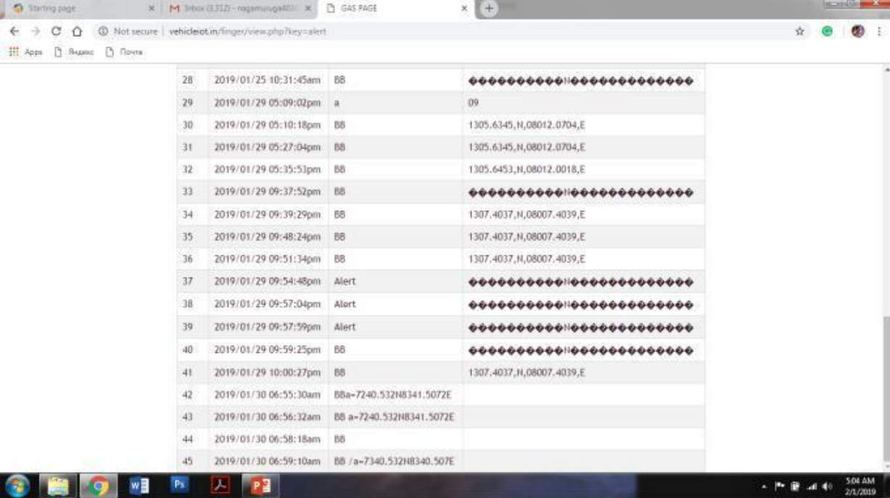

**Conclusion:**

This project is good at cost efficient and easy in assembling the circuit also highly efficient in means of practical. If our project came into existence this vehicle they will definitely drop to 3 or 2 vehicles a week in our society.